PLOTS OF RMC ASSIGNMENT 4

Q3. Part: b

1. Zero Input Response

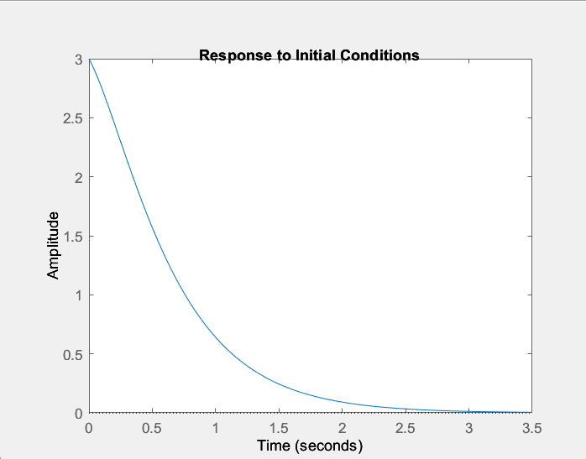

1. Unit Step Response

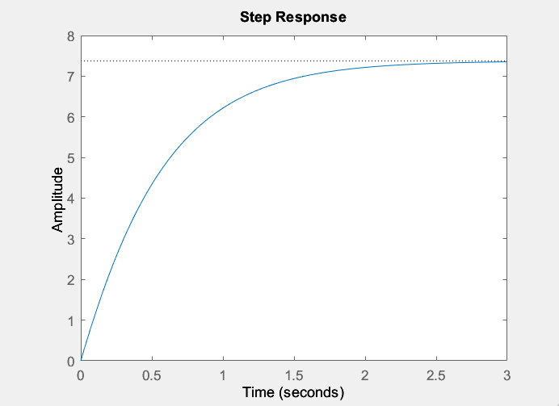

1. General Response

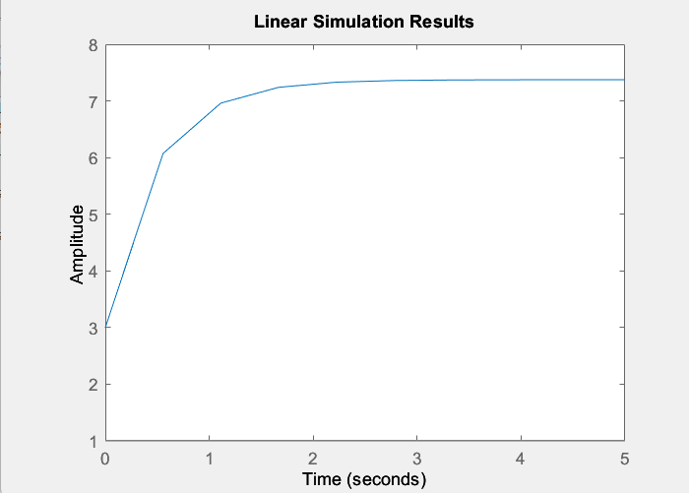

Q4. Unit Step Response

G(s) = 25 / s^2 + 4s + 25

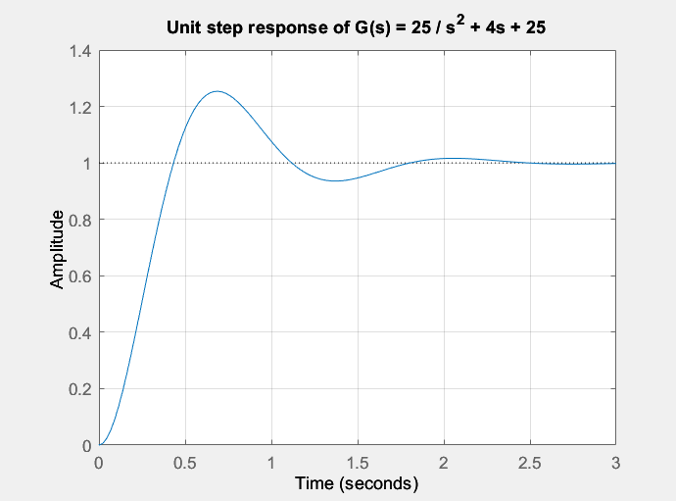

Q7. Root Locus

G(s) = k \* (s+3) / s \* (s + 1) \* (s^2 + 4s + 16)

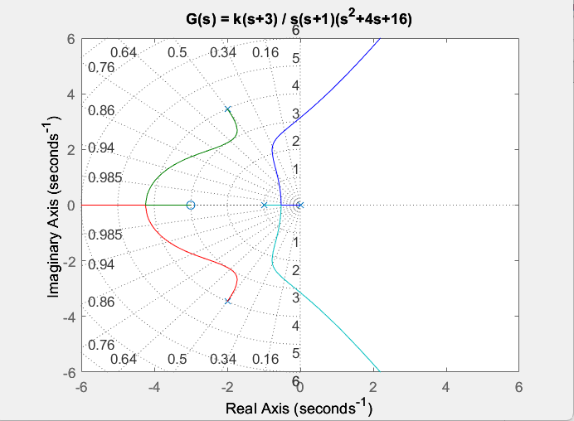

Q8. Step Response

Before: G(s) = 1 / (s – 1)^2

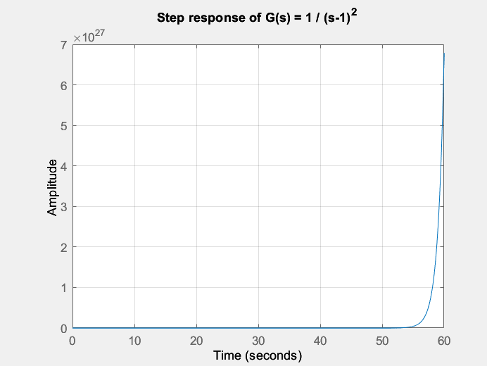

After: G(s) = 10s + 10 / s^3 + s^2 + 9s + 12

K = 10, z = 1, p = 2

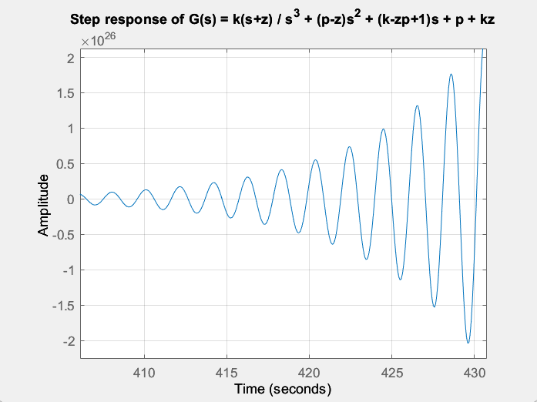

Q5. Response of 2DOF planar arm

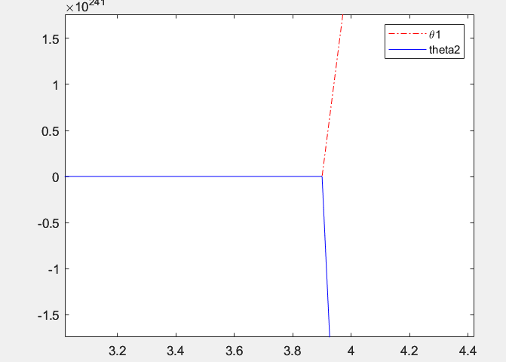

Q6. Response

